23 Type Specific ECDIS ACAT Courses Now Available Off-Line From £8 Per Seafarer
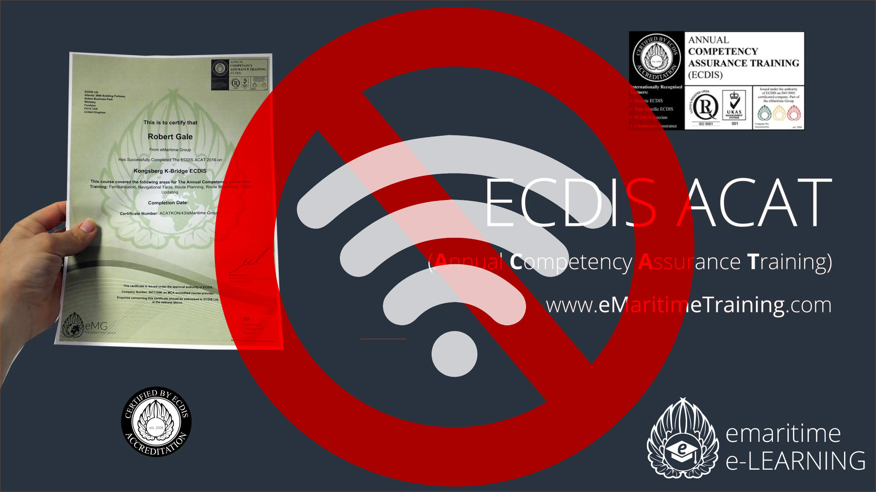

ECDIS Ltd have further developed their successful, not for profit, Annual Competency Assurance Training (ACAT) courses by introducing an offline version.

[Whiteley, Hampshire January 2017] Listening to the requirements of many of their clients with little or no internet onboard, ECDIS Ltd have developed an efficient offline solution of all of ACAT courses, removing the need for constant internet connection.

The courses share the exact same content as their online counterparts, however the courses can be purchased and downloaded ashore or when internet is available, and run on any Windows PC for up to 365 days, making this a highly versatile solution for many shipping companies, who do not yet have internet access at sea for their seafarers to complete their training needs when away from home/college.

This is another package in which ECDIS Ltd are continuing to provide diverse training opportunities for the maritime industry, in order to support mariners blended learning requirements
George Ward from ECDIS Ltd, one of the key architects and developers of the ACAT courses, states:

"We have had incredible interest and uptake of our new ECDIS ACAT courses. But we are acutely conscious of the fact that many shipping companies globally are yet to implement reliable (or indeed any) internet onboard their vessels. As such we have invested heavily in rolling out a new format for ACAT running parallel with the existing online training solutions already available"

The courses are available as two different license options; a single license for individual crew costing £15 per year, and a "per hull" option at £150 per year, enabling companies to register an entire hull with unlimited crew.

Once the course has been completed by a student, they simply email a unique verification code to ECDIS Ltd HQ and are issued with a digital copy of their certificate, valid for 365 days.

"We are always looking for new cutting-edge ways of training the industry and adding additional levels of safety and quality assurance to a company's crew competency. Our new Offline ACAT gives that by offering greater flexibility and accessibility for shipping companies" - Mark Broster, ECDIS Ltd Managing Director

For further details of all ACAT courses, please visit www.emaritimetraining.com

(NB: Cost £8 per seafarer based on an a typical 18 crew members per ship)

End.
For more information please contact Mike Backhouse | Head of Marketing | backhouse@ecdis.org

About ECDIS Ltd
ECDIS Ltd is a privately owned UK registered company. Originally offering just the IMO 1.27 Generic ECDIS course, it went on to become the largest global independent company in its field, now offering 35 STCW courses.
As a training company with a wide portfolio of courses ranging from Deck to Security, ECDIS Ltd has a growing client base of 150 large commercial shipping companies, governments and military clients spanning every continent. Over the last five-year trading period, ECDIS Ltd has achieved a documented 96% perfection feedback on training courses and 98% for equipment. www.ecdis.org

