ECDIS Ltd Delivers Their First JRC Training on The New 9201 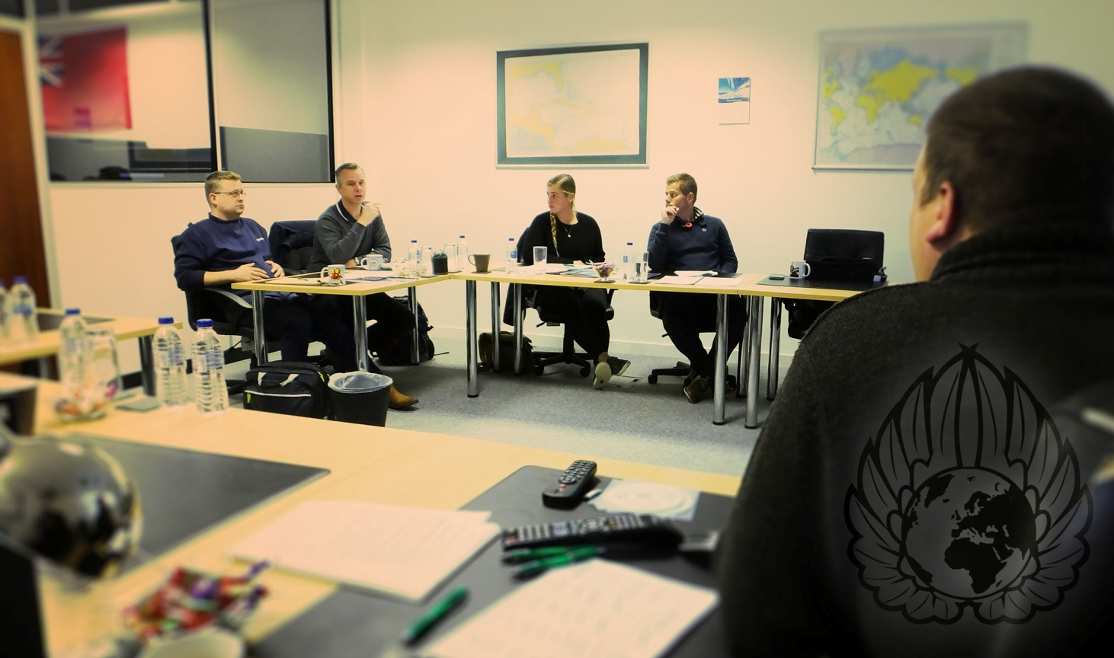

ECDIS Ltd are proud to announce they have extended their course portfolio to include a new Type Specific JRC 9201 training course.

[Whiteley, Hampshire November 2016] The one day course has been written to the same exacting standards the industry has come to expect from ECDIS Ltd.

The feedback from the course was "very high" across the board, when asked how much more knowledgeable they feel on the JRC 9201 ECDIS system, they said "very much so" and are "confident enough to use [their] equipment on-board". It was also said that the instructor had a "high Level of base knowledge to use the piece of equipment."

When asked "have you seen anything you liked in another establishment that ECDIS Ltd could take on" one student stated "[No,] It is other establishments that need to take note of ECDIS Ltd"

Robert Hinton from Serco Marine Services sums up his time at ECDIS Ltd:

" It is thoroughly refreshing to visit a training provider that has captured what customers really want......excellent facilities and equipment, quality complimentary refreshments and snacks but at the same time, and most importantly, delivering a quality course with passion, therefore delivering value for money overall. There are too many providers around nowadays that are quite happy to take people's money but deliver a sub standard course and facilities and with little knowledge and understanding"

End.
For more information please contact Mike Backhouse | Digital Marketing Manager| backhouse@ecdis.org

About ECDIS Ltd
ECDIS Ltd is a privately owned UK registered company. Originally offering just the IMO 1.27 Generic ECDIS course, it went on to become the largest global independent company in its field, now offering 35 STCW courses. In 2014 ECDIS Ltd was awarded runner-up in the UK National Business awards for International Growth.
As a training company with a wide portfolio of courses ranging from Deck to Security, ECDIS Ltd has a growing client base of 150 large commercial shipping companies, governments and military clients spanning every continent. Over the last five-year trading period, ECDIS Ltd has achieved a documented 96% perfection feedback on training courses and 98% for equipment. www.ecdis.org

