ECDIS Ltd Enter the Second Phase of Their International Seminars in Dubai
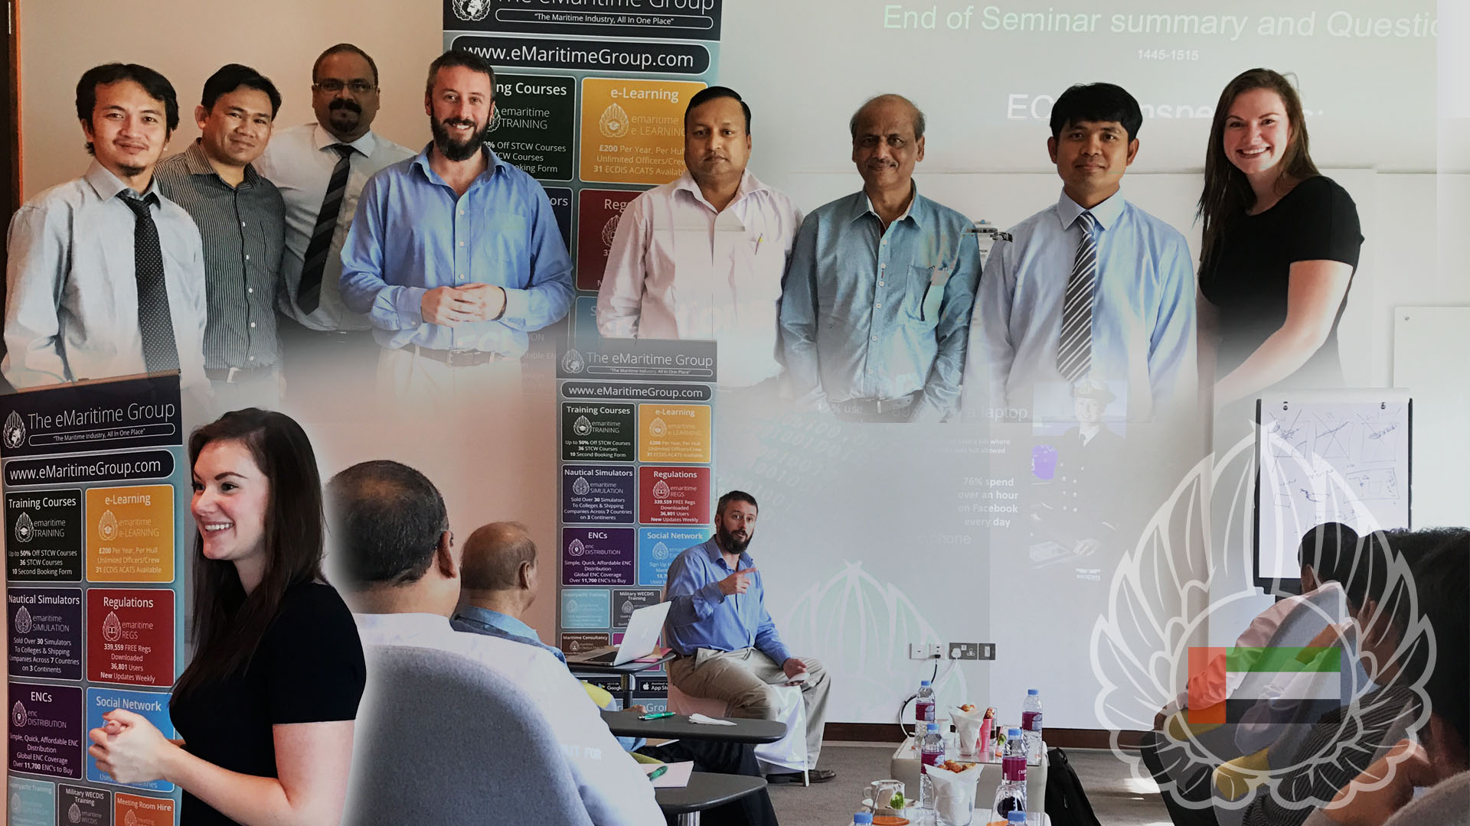
(Photo: Images from ECDIS Ltd Seminar in Dubai)

ECDIS Ltd's international seminars on have proven such a success, they have now moved into a new series; starting with the one of the previous hosts, Dubai.

[Whiteley, Hampshire 14 November 2016] The seminar, held on 3rd November at the InterContinental Hotel Dubai, gave the attendees a great opportunity to interact directly with the speakers in a round table discussion style forum, gaining invaluable insight and knowledge to enhance company procedures.

The seminar titled "ECDIS Inspections: Marine Risk Reduction, Detentions & Best Practice" provides the delegates with practical, insightful knowledge of the best ways to prevent lengthy, costly port detentions; something which all global shipping companies want to avoid.

Feedback from the attendees was outstanding:

"An excellent seminar addressing various issues related to ECDIS usage and implementation. As informed by previous participants, [the] interaction with the instructor and sharing of knowledge was excellent. [They] addressed issues which were not covered in usual ECDIS training."

Dubai, yet again made the team feel very welcome, and provided the perfect learning environment. The next stop for the team is Manila, Philippines on Thursday 17th November. For more information on the seminars, and for those interested in attending any future seminars visit www.ecdis.org/seminars or email seminars@ecdis.org.

End.
For more information please contact Mike Backhouse | Digital Marketing Manager| backhouse@ecdis.org

About ECDIS Ltd
ECDIS Ltd is a privately owned UK registered company. Originally offering just the IMO 1.27 Generic ECDIS course, it went on to become the largest global independent company in its field, now offering 35 STCW courses. In 2014 ECDIS Ltd was awarded runner-up in the UK National Business awards for International Growth.
As a training company with a wide portfolio of courses ranging from Deck to Security, ECDIS Ltd has a growing client base of 150 large commercial shipping companies, governments and military clients spanning every continent. Over the last five-year trading period, ECDIS Ltd has achieved a documented 96% perfection feedback on training courses and 98% for equipment. www.ecdis.org

